**MOBILE APPLICATION DEVELOPMENT LAB**

**BHAGYAMOL MADHU**

**20MCA019**

# CYCLE-1

# 1.Design a Login page

## activity_main.xml

<LinearLayout

android:layout_height="match_parent" android:layout_width="match_parent" android:orientation="vertical" xmlns:android="<http://schemas.android.com/apk/res/android>">

<TextView

android:layout_width="match_parent" android:layout_height="wrap_content" android:text="LOGIN FORM" android:textSize="32sp" android:gravity="center" android:textColor="#3049b0" />

<EditText

android:layout_width="match_parent" android:layout_height="wrap_content" android:id="@+id/et1" android:hint="username"/>

<EditText

android:layout_width="match_parent" android:layout_height="wrap_content" android:id="@+id/et2" android:hint="password" android:inputType="textPassword"/>

<Button

android:layout_width="match_parent" android:layout_height="wrap_content" android:id="@+id/b1" android:text="LOGIN" android:onClick="LOGIN" />

<Button

android:layout_width="match_parent" android:layout_height="wrap_content" android:id="@+id/b2" android:text="CANCEL" android:onClick="CANCEL"/>

</LinearLayout>

## MainActivity.java

**package** com.example.sjcet.loginpage;

**import** android.support.v7.app.AppCompatActivity;

**import** android.os.Bundle;

**public class** MainActivity **extends** AppCompatActivity { @Override

**protected void** onCreate(Bundle savedInstanceState) { **super**.onCreate(savedInstanceState); setContentView(R.layout.***activity_main***);

}

}

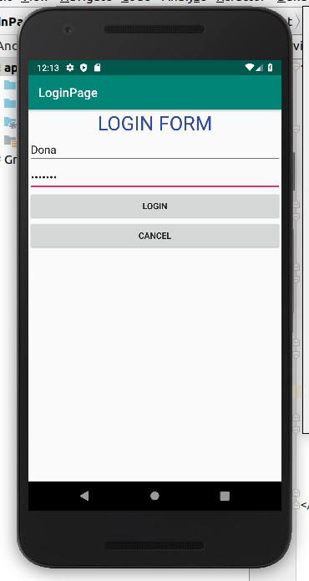

# 2.Change the content in the TextView on a button click.

## activity_main.xml

<LinearLayout

android:layout_height="match_parent" android:layout_width="match_parent" android:orientation="vertical" xmlns:android="<http://schemas.android.com/apk/res/android>">

<TextView

android:layout_width="match_parent" android:layout_height="wrap_content" android:text="Welcome" android:id="@+id/tv1" android:textSize="32sp"/>

<Button

android:layout_width="match_parent" android:layout_height="wrap_content" android:id="@+id/b1" android:text="Change" android:onClick="click"/>

</LinearLayout> MainActivity.java

**package** com.example.sjcet.changecontenttextview; **import** android.support.v7.app.AppCompatActivity; **import** android.os.Bundle;

**import** android.view.View;

**import** android.widget.TextView;

**public class** MainActivity **extends** AppCompatActivity { @Override

**protected void** onCreate(Bundle savedInstanceState) { **super**.onCreate(savedInstanceState); setContentView(R.layout.***activity_main***);

}

**public void** click(View view) {

TextView tv = (TextView)findViewById(R.id.***tv1***); tv.setText(**"Welcome to android"**);

}

**}**

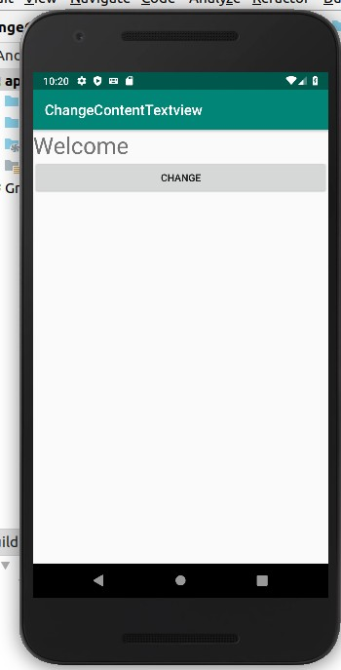 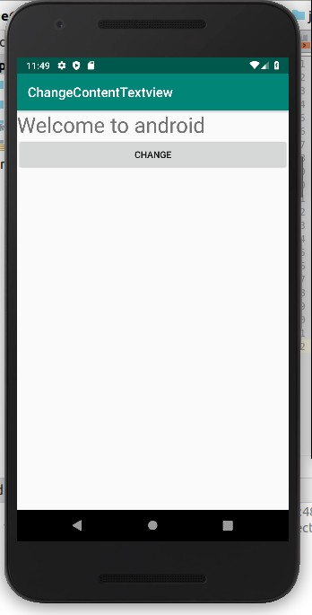

# 3.Read a content from EditText and print it in a TextView

## activity_main.xml

<LinearLayout

android:layout_width="match_parent" android:layout_height="match_parent" android:orientation="vertical" android:gravity="center"

xmlns:android="<http://schemas.android.com/apk/res/android>">

<TextView

android:layout_width="wrap_content" android:layout_height="wrap_content" android:id="@+id/tv" android:text="Dona"/>

<EditText

android:layout_width="wrap_content" android:layout_height="wrap_content" android:id="@+id/et" android:hint="Enter Text"/>

<Button

android:layout_width="wrap_content" android:layout_height="wrap_content" android:id="@+id/btn" android:text="Change TextView" android:onClick="click"/>

</LinearLayout> MainActivity.java

**package** com.example.sjcet.readfromedittext; **import** android.support.v7.app.AppCompatActivity; **import** android.os.Bundle;

**import** android.view.View; **import** android.widget.EditText; **import** android.widget.TextView;

**public class** MainActivity **extends** AppCompatActivity { TextView **tv**;

EditText **et**; @Override

**protected void** onCreate(Bundle savedInstanceState) { **super**.onCreate(savedInstanceState); setContentView(R.layout.***activity_main***);

}

**public void** click(View view) {

**tv** = findViewById(R.id.***tv***); **et** = findViewById(R.id.***et***); **tv**.setText(**et**.getText());

}

**}**

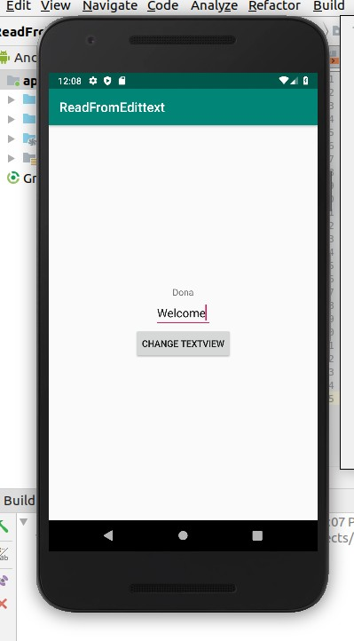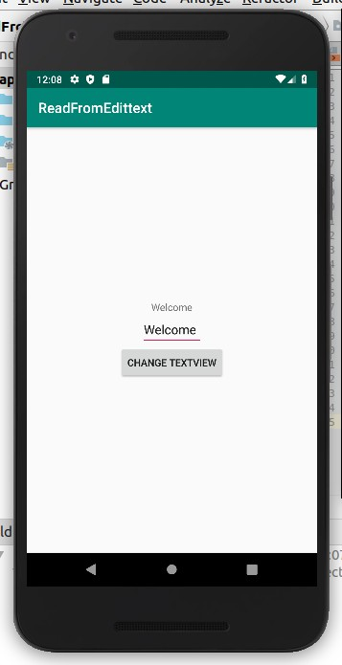

# 4.Change the background color on a button click

## activity_main.xml

<**LinearLayout android:id="@+id/l1"**

android:layout_height="match_parent" android:layout_width="match_parent" xmlns:android="<http://schemas.android.com/apk/res/android>" xmlns:tools="[http://schemas.android.com/tools"](http://schemas.android.com/tools)>

<Button

android:id="@+id/button" android:layout_width="250dp" android:layout_height="wrap_content" android:padding="20dp" android:layout_marginLeft="70dp" android:layout_marginTop="190dp" android:text="Click here to change color" />

</LinearLayout>

## MainActivity.java

**package** com.example.sjcet.myapplication;

**import** android.support.v7.app.AppCompatActivity;

**import** android.os.Bundle; **import** android.view.View; **import** android.widget.Button;

**import** android.widget.LinearLayout;

**public class** MainActivity **extends** AppCompatActivity { @Override

**protected void** onCreate(Bundle savedInstanceState) { **super**.onCreate(savedInstanceState); setContentView(R.layout.***activity_main***); Button button1;

**final** LinearLayout Layout; Layout =findViewById(R.id.***l1***);

button1 = findViewById(R.id.***button***); button1.setOnClickListener(**new** View.OnClickListener() {

@Override

**public void** onClick(View v) { Layout.setBackgroundResource(R.color.***colorPrimaryDark***);

}

});

}

}

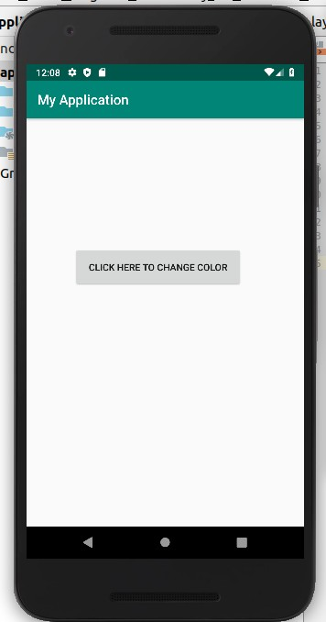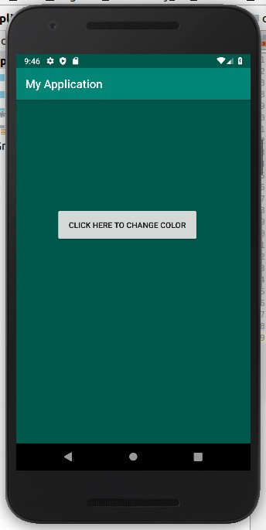

# 5.Create a sample calculator

## activity_main.xml

<**RelativeLayout xmlns:android="**[**http://schemas.android.com/apk/res/android**](http://schemas.android.com/apk/res/android)**"**

xmlns:tools="[http://schemas.android.com/tools"](http://schemas.android.com/tools) android:id="@+id/relative1" android:layout_width="match_parent" android:layout_height="match_parent" tools:context=".MainActivity">

<EditText

android:id="@+id/edt1"

android:layout_width="match_parent" android:layout_height="wrap_content" />

<Button

android:id="@+id/button1" style="?android:attr/buttonStyleSmall" android:layout_width="wrap_content" android:layout_height="wrap_content" android:layout_alignEnd="@+id/button4" android:layout_alignRight="@+id/button4" android:layout_below="@+id/edt1" android:layout_marginTop="94dp" android:text="1" />

<Button

android:id="@+id/button2" style="?android:attr/buttonStyleSmall" android:layout_width="wrap_content" android:layout_height="wrap_content" android:layout_alignTop="@+id/button1" android:layout_toLeftOf="@+id/button3" android:layout_toStartOf="@+id/button3" android:text="2" />

<Button

android:id="@+id/button3" style="?android:attr/buttonStyleSmall" android:layout_width="wrap_content" android:layout_height="wrap_content" android:layout_alignTop="@+id/button2" android:layout_centerHorizontal="true" android:text="3" />

<Button

android:id="@+id/button4" style="?android:attr/buttonStyleSmall" android:layout_width="wrap_content" android:layout_height="wrap_content" android:layout_below="@+id/button1" android:layout_toLeftOf="@+id/button2" android:text="4" />

<Button

android:id="@+id/button5" style="?android:attr/buttonStyleSmall" android:layout_width="wrap_content" android:layout_height="wrap_content" android:layout_alignBottom="@+id/button4" android:layout_alignLeft="@+id/button2" android:layout_alignStart="@+id/button2" android:text="5" />

<Button

android:id="@+id/button6" style="?android:attr/buttonStyleSmall" android:layout_width="wrap_content" android:layout_height="wrap_content" android:layout_alignLeft="@+id/button3" android:layout_alignStart="@+id/button3" android:layout_below="@+id/button3" android:text="6" />

<Button

android:id="@+id/button7" style="?android:attr/buttonStyleSmall" android:layout_width="wrap_content" android:layout_height="wrap_content" android:layout_below="@+id/button4" android:layout_toLeftOf="@+id/button2" android:text="7" />

<Button

android:id="@+id/button8" style="?android:attr/buttonStyleSmall" android:layout_width="wrap_content" android:layout_height="wrap_content" android:layout_alignLeft="@+id/button5"

android:layout_alignStart="@+id/button5" android:layout_below="@+id/button5" android:text="8" />

<Button

android:id="@+id/button9" style="?android:attr/buttonStyleSmall" android:layout_width="wrap_content" android:layout_height="wrap_content" android:layout_alignLeft="@+id/button6" android:layout_alignStart="@+id/button6" android:layout_below="@+id/button6" android:text="9" />

<Button

android:id="@+id/buttonadd" style="?android:attr/buttonStyleSmall" android:layout_width="wrap_content" android:layout_height="wrap_content" android:layout_alignEnd="@+id/edt1" android:layout_alignRight="@+id/edt1" android:layout_alignTop="@+id/button3" android:layout_marginLeft="46dp" android:layout_marginStart="46dp" android:layout_toRightOf="@+id/button3" android:text="+" />

<Button

android:id="@+id/buttonsub" style="?android:attr/buttonStyleSmall" android:layout_width="wrap_content" android:layout_height="wrap_content" android:layout_alignEnd="@+id/buttonadd" android:layout_alignLeft="@+id/buttonadd" android:layout_alignRight="@+id/buttonadd" android:layout_alignStart="@+id/buttonadd" android:layout_below="@+id/buttonadd" android:text="-" />

<Button

android:id="@+id/buttonmul" style="?android:attr/buttonStyleSmall" android:layout_width="wrap_content" android:layout_height="wrap_content" android:layout_alignLeft="@+id/buttonsub" android:layout_alignParentEnd="true" android:layout_alignParentRight="true" android:layout_alignStart="@+id/buttonsub" android:layout_below="@+id/buttonsub" android:text="*" />

<Button

android:id="@+id/button10" style="?android:attr/buttonStyleSmall" android:layout_width="wrap_content" android:layout_height="wrap_content" android:layout_below="@+id/button7" android:layout_toLeftOf="@+id/button2" android:text="." />

<Button

android:id="@+id/button0" style="?android:attr/buttonStyleSmall" android:layout_width="wrap_content" android:layout_height="wrap_content" android:layout_alignLeft="@+id/button8" android:layout_alignStart="@+id/button8" android:layout_below="@+id/button8" android:text="0" />

<Button

android:id="@+id/buttonC" style="?android:attr/buttonStyleSmall" android:layout_width="wrap_content" android:layout_height="wrap_content" android:layout_alignLeft="@+id/button9"

android:layout_alignStart="@+id/button9" android:layout_below="@+id/button9" android:text="C" />

<Button

android:id="@+id/buttondiv" style="?android:attr/buttonStyleSmall" android:layout_width="wrap_content" android:layout_height="wrap_content" android:layout_alignEnd="@+id/buttonmul" android:layout_alignLeft="@+id/buttonmul" android:layout_alignRight="@+id/buttonmul" android:layout_alignStart="@+id/buttonmul" android:layout_below="@+id/buttonmul" android:text="/" />

<Button

android:id="@+id/buttoneql" android:layout_width="wrap_content" android:layout_height="wrap_content" android:layout_alignEnd="@+id/buttondiv" android:layout_alignLeft="@+id/button10" android:layout_alignRight="@+id/buttondiv" android:layout_alignStart="@+id/button10" android:layout_below="@+id/button0" android:layout_marginTop="37dp" android:text="=" />

</RelativeLayout>

## MainActivity.java

**package com.example.sjcet.a5_calculator;**

**import** android.support.v7.app.AppCompatActivity;

**import** android.os.Bundle; **import** android.text.Editable; **import** android.view.View; **import** android.widget.Button; **import** android.widget.EditText; **import** android.widget.TextView;

**public class** MainActivity **extends** AppCompatActivity {

Button **button0**, **button1**, **button2**, **button3**, **button4**, **button5**, **button6**, **button7**, **button8**,**button9**, **buttonAdd**, **buttonSub**, **buttonDivision**, **buttonMul**, **button10**, **buttonC**, **buttonEqual**;

EditText **crunchifyEditText**; **float mValueOne**, **mValueTwo**;

boolean crunchifyAddition, mSubtract, crunchifyMultiplication, crunchifyDivision; @Override

**protected void** onCreate(Bundle savedInstanceState) { **super**.onCreate(savedInstanceState); setContentView(R.layout.***activity_main***); **button0** = (Button) findViewById(R.id.***button0***); **button1** = (Button) findViewById(R.id.***button1***); **button2** = (Button) findViewById(R.id.***button2***); **button3** = (Button) findViewById(R.id.***button3***); **button4** = (Button) findViewById(R.id.***button4***); **button5** = (Button) findViewById(R.id.***button5***); **button6** = (Button) findViewById(R.id.***button6***); **button7** = (Button) findViewById(R.id.***button7***); **button8** = (Button) findViewById(R.id.***button8***); **button9** = (Button) findViewById(R.id.***button9***);

**button10** = (Button) findViewById(R.id.***button10***); **buttonAdd** = (Button) findViewById(R.id.***buttonadd***); **buttonSub** = (Button) findViewById(R.id.***buttonsub***); **buttonMul** = (Button) findViewById(R.id.***buttonmul***); **buttonDivision** = (Button) findViewById(R.id.***buttondiv***); **buttonC** = (Button) findViewById(R.id.***buttonC***);

**buttonEqual** = (Button) findViewById(R.id.***buttoneql***); **crunchifyEditText** = (EditText) findViewById(R.id.***edt1***); **button1**.setOnClickListener(**new** View.OnClickListener() {

@Override

**public void** onClick(View v) {

**crunchifyEditText**.setText(**crunchifyEditText**.getText() + **"1"**);

}

});

**button2**.setOnClickListener(**new** View.OnClickListener() { @Override

**public void** onClick(View v) {

**crunchifyEditText**.setText(**crunchifyEditText**.getText() + **"2"**);

}

});

**button3**.setOnClickListener(**new** View.OnClickListener() { @Override

**public void** onClick(View v) {

**crunchifyEditText**.setText(**crunchifyEditText**.getText() + **"3"**);

});

}

**button4**.setOnClickListener(**new** View.OnClickListener() { @Override

**public void** onClick(View v) {

**crunchifyEditText**.setText(**crunchifyEditText**.getText() + **"4"**);

}

});

**button5**.setOnClickListener(**new** View.OnClickListener() { @Override

**public void** onClick(View v) {

**crunchifyEditText**.setText(**crunchifyEditText**.getText() + **"5"**);

}

});

**button6**.setOnClickListener(**new** View.OnClickListener() { @Override

**public void** onClick(View v) {

**crunchifyEditText**.setText(**crunchifyEditText**.getText() + **"6"**);

}

});

**button7**.setOnClickListener(**new** View.OnClickListener() { @Override

**public void** onClick(View v) {

**crunchifyEditText**.setText(**crunchifyEditText**.getText() + **"7"**);

}

});

**button8**.setOnClickListener(**new** View.OnClickListener() { @Override

**public void** onClick(View v) {

**crunchifyEditText**.setText(**crunchifyEditText**.getText() + **"8"**);

}

});

**button9**.setOnClickListener(**new** View.OnClickListener() { @Override

**public void** onClick(View v) {

**crunchifyEditText**.setText(**crunchifyEditText**.getText() + **"9"**);

}

});

**button0**.setOnClickListener(**new** View.OnClickListener() { @Override

**public void** onClick(View v) {

**crunchifyEditText**.setText(**crunchifyEditText**.getText() + **"0"**);

}

});

**buttonAdd**.setOnClickListener(**new** View.OnClickListener() { @Override

**public void** onClick(View v) {

**if** (**crunchifyEditText** == **null**){ **crunchifyEditText**.setText(**""**);

}**else** {

**mValueOne** = Float.*parseFloat*(**crunchifyEditText**.getText() + **""**);

}

});

**crunchifyAddition** = **true**; **crunchifyEditText**.setText(**null**);

}

**buttonSub**.setOnClickListener(**new** View.OnClickListener() { @Override

**public void** onClick(View v) {

**mValueOne** = Float.*parseFloat*(**crunchifyEditText**.getText() + **""**); **mSubtract** = **true**;

**crunchifyEditText**.setText(**null**);

}

});

**buttonMul**.setOnClickListener(**new** View.OnClickListener() { @Override

**public void** onClick(View v) {

**mValueOne** = Float.*parseFloat*(**crunchifyEditText**.getText() + **""**); **crunchifyMultiplication** = **true**;

**crunchifyEditText**.setText(**null**);

}

});

**buttonDivision**.setOnClickListener(**new** View.OnClickListener() { @Override

**public void** onClick(View v) {

**mValueOne** = Float.*parseFloat*(**crunchifyEditText**.getText() + **""**); **crunchifyDivision** = **true**;

**crunchifyEditText**.setText(**null**);

}

});

**buttonEqual**.setOnClickListener(**new** View.OnClickListener() { @Override

**public void** onClick(View v) {

**mValueTwo** = Float.*parseFloat*(**crunchifyEditText**.getText() + **""**); **if** (**crunchifyAddition** == **true**) {

**crunchifyEditText**.setText(**mValueOne** + **mValueTwo** + **""**); **crunchifyAddition** = **false**;

}

**if** (**mSubtract** == **true**) {

**crunchifyEditText**.setText(**mValueOne** - **mValueTwo** + **""**); **mSubtract** = **false**;

}

**if** (**crunchifyMultiplication** == **true**) { **crunchifyEditText**.setText(**mValueOne** * **mValueTwo** + **""**); **crunchifyMultiplication** = **false**;

}

**if** (**crunchifyDivision** == **true**) { **crunchifyEditText**.setText(**mValueOne** / **mValueTwo** + **""**); **crunchifyDivision** = **false**;

}

}

});

**buttonC**.setOnClickListener(**new** View.OnClickListener() { @Override

**public void** onClick(View v) {

**crunchifyEditText**.setText(**""**);

}

});

**button10**.setOnClickListener(**new** View.OnClickListener() { @Override

**public void** onClick(View v) {

**crunchifyEditText**.setText(**crunchifyEditText**.getText() + **"."**);

}

});

}

}

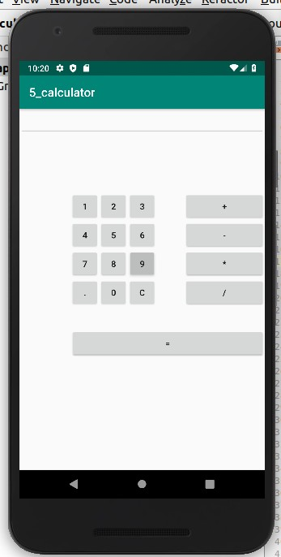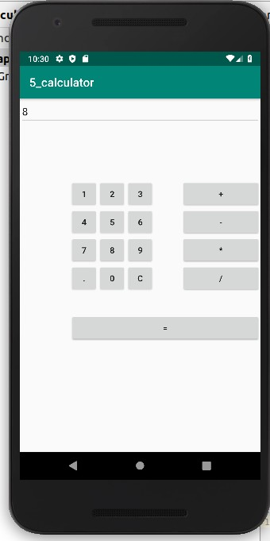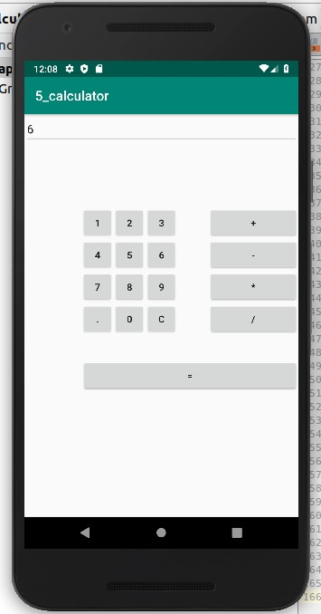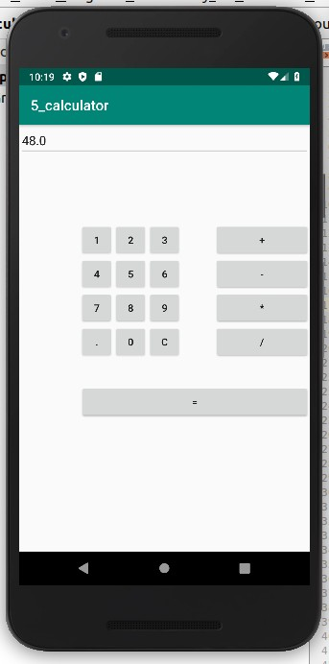

***CYCLE-2***

***1.Create 2 Activities from 1st Activity on click move to 2nd activity (Using Intent)***

***activity-main.xml***

***<?xml version="1.0" encoding="utf-8"?>***

<**LinearLayout**

**android:id="@+id/p1"**

**android:layout_width="match_parent"**

**android:layout_height="match_parent"**

**android:orientation="vertical"**

**android:gravity="center"**

**xmlns:android="http://schemas.android.com/apk/res/android"**>

<**Button**

**android:layout_width="wrap_content"**

**android:layout_height="wrap_content"**

**android:gravity="center"**

**android:onClick="click"**

**android:text="Click"**/>

</**LinearLayout**>

***MainActivity.java***

***package com.example.sjcet.twoactivity;***

**import** android.support.v7.app.AppCompatActivity;

**import** android.os.Bundle;

**import** android.view.View;

**import** android.content.Intent;

**import** android.widget.Button;

**public class** MainActivity **extends** AppCompatActivity {

@Override

**protected void** onCreate(Bundle savedInstanceState) {

**super**.onCreate(savedInstanceState);

setContentView(R.layout.***activity_main***);

}

**public void** click(View view) {

Opennewactivity();

}

**public void** Opennewactivity()

{

Intent intent=**new** Intent(**this**,Main2Activity.**class**);

startActivity(intent);

}

}

***activity-main2.xml***

***<?xml version="1.0" encoding="utf-8"?>***

<**android.support.constraint.ConstraintLayout**

**xmlns:android="http://schemas.android.com/apk/res/android"**

**xmlns:app="http://schemas.android.com/apk/res-auto"**

**xmlns:tools="http://schemas.android.com/tools"**

**android:layout_width="match_parent"**

**android:layout_height="match_parent"**

**android:layout_gravity="center"**

**tools:context=".Main2Activity"**>

<**TextView**

**android:layout_width="wrap_content"**

**android:layout_height="wrap_content"**

**android:gravity="center"**

**android:text="Activity 2"**

**tools:layout_editor_absoluteX="164dp"**

**tools:layout_editor_absoluteY="237dp"** />

</**android.support.constraint.ConstraintLayout**>

***Main2Activity.java***

***package com.example.sjcet.twoactivity;***

**import** android.support.v7.app.AppCompatActivity;

**import** android.os.Bundle;

**public class** Main2Activity **extends** AppCompatActivity {

@Override

**protected void** onCreate(Bundle savedInstanceState) {

**super**.onCreate(savedInstanceState);

setContentView(R.layout.***activity_main2***);

}

}

***OUTPUT***

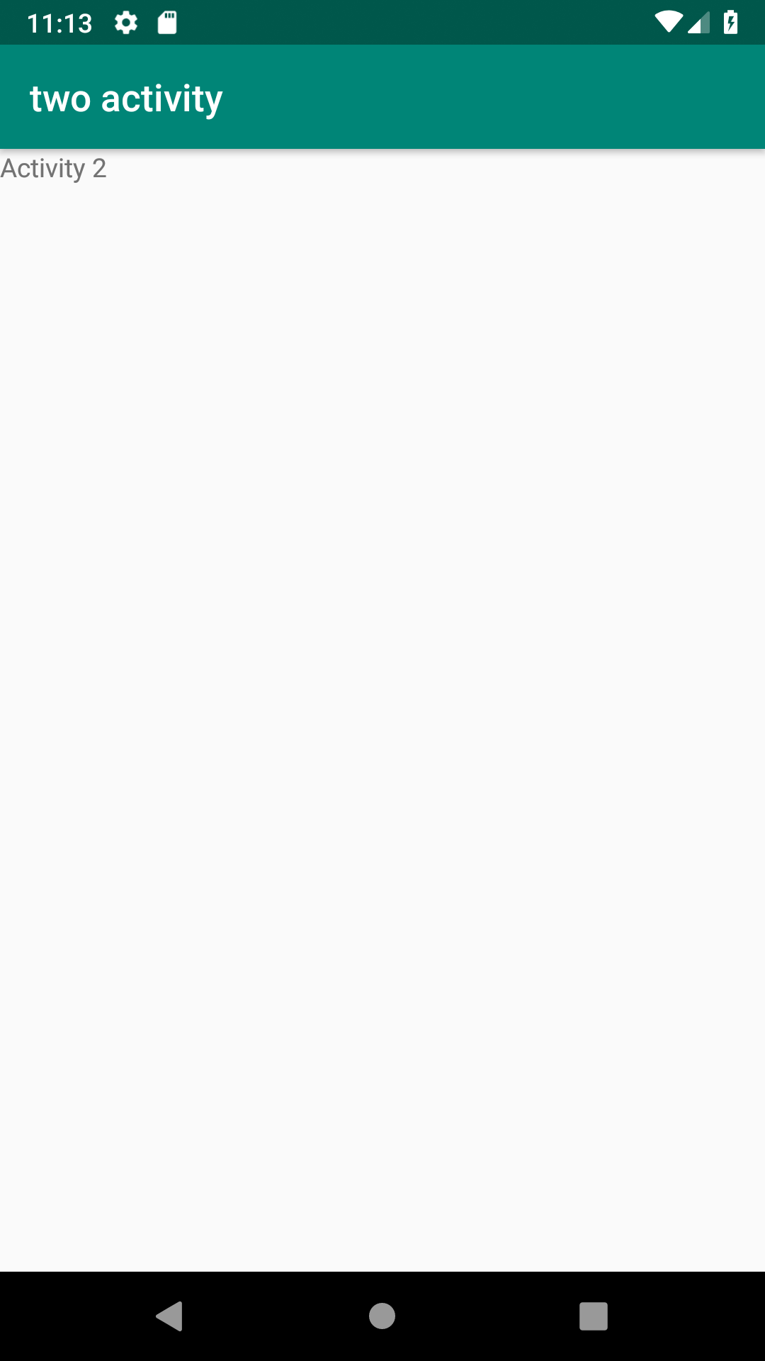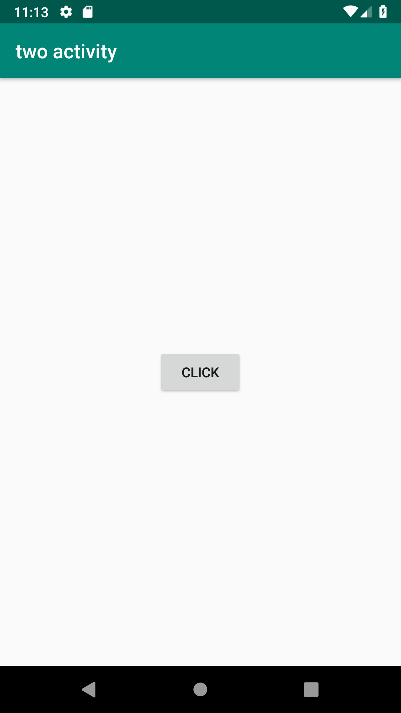

***2.Create an Activity and move to facebook login page on a button click(making use of Intent).***

***activity-main.xml***

***package com.example.sjcet.facebook;***

**import** android.content.Intent;

**import** android.net.Uri;

**import** android.support.v7.app.AppCompatActivity;

**import** android.os.Bundle;

**import** android.view.View;

**import** android.widget.Button;

**public class** MainActivity **extends** AppCompatActivity {

Button **btn**;

@Override

**protected void** onCreate(Bundle savedInstanceState) {

**super**.onCreate(savedInstanceState);

setContentView(R.layout.***activity_main***);

**btn** = findViewById(R.id.***btn***);

**btn**.setOnClickListener(**new** View.OnClickListener() {

@Override

**public void** onClick(View v) {

Intent intent = **new** Intent(Intent.***ACTION_VIEW***,Uri.*parse*(**"https://www.facebook.com/"**));

startActivity(intent);

}

});

}

}

***MainActivity.java***

***package com.example.sjcet.facebook;***

**import** android.content.Intent;

**import** android.net.Uri;

**import** android.support.v7.app.AppCompatActivity;

**import** android.os.Bundle;

**import** android.view.View;

**import** android.widget.Button;

**public class** MainActivity **extends** AppCompatActivity {

Button **btn**;

@Override

**protected void** onCreate(Bundle savedInstanceState) {

**super**.onCreate(savedInstanceState);

setContentView(R.layout.***activity_main***);

**btn** = findViewById(R.id.***btn***);

**btn**.setOnClickListener(**new** View.OnClickListener() {

@Override

**public void** onClick(View v) {

Intent intent = **new** Intent(Intent.***ACTION_VIEW***,Uri.*parse*(**"https://www.facebook.com/"**));

startActivity(intent);

}

});

}

}

***OUTPUT***

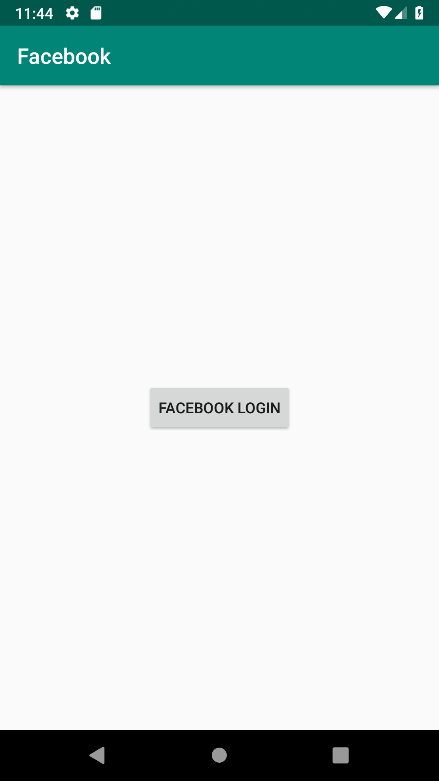

***3.*****Read message from 1st Activity and pass it onto the 2nd Activity on a button click**

**activity_main.xml**

***<?*xml version="1.0" encoding="utf-8"*?>***

<**RelativeLayout**

**xmlns:android="http://schemas.android.com/apk/res/android"**

**xmlns:app="http://schemas.android.com/apk/res-auto"**

**xmlns:tools="http://schemas.android.com/tools"**

**android:layout_width="match_parent"**

**android:layout_height="match_parent"**

**tools:context=".first_activity"**>

<**EditText**

**android:id="@+id/send_text_id"**

**android:layout_width="300dp"**

**android:layout_height="wrap_content"**

**android:textSize="25dp"**

**android:hint="Input"**

**android:textStyle="bold"**

**android:layout_marginTop="20dp"**

**android:layout_marginLeft="40dp"**/>

<**Button**

**android:id="@+id/send_button_id"**

**android:layout_width="wrap_content"**

**android:layout_height="40dp"**

**android:text="send"**

**android:textStyle="bold"**

**android:layout_marginTop="150dp"**

**android:layout_marginLeft="150dp"**/>

</**RelativeLayout**>

**activity_main2.xml**

*<?***xml version="1.0" encoding="utf-8"***?>*

<**RelativeLayout xmlns:android="http://schemas.android.com/apk/res/android"**

**xmlns:app="http://schemas.android.com/apk/res-auto"**

**xmlns:tools="http://schemas.android.com/tools"**

**android:layout_width="match_parent"**

**android:layout_height="match_parent"**

**tools:context="org.HELLO WORLD.navedmalik.sendthedata.Second_activity"**>

<**TextView**

**android:id="@+id/received_value_id"**

**android:layout_width="300dp"**

**android:layout_height="50dp"**

**android:textStyle="bold"**

**android:textSize="40dp"**

**android:layout_marginTop="20dp"**

**android:layout_marginLeft="40dp"**/>

</**RelativeLayout**>

**MainActivity.java**

**package com.example.sjcet.messagepassing;**

**import** android.content.Intent;

**import** android.support.v7.app.AppCompatActivity;

**import** android.os.Bundle;

**import** android.view.View;

**import** android.widget.Button;

**import** android.widget.EditText;

**public class** MainActivity **extends** AppCompatActivity {

*// define the variable*

Button **send_button**;

EditText **send_text**;

@Override

**protected void** onCreate(Bundle savedInstanceState) {

**super**.onCreate(savedInstanceState);

setContentView(R.layout.***activity_main***);

**send_button** = (Button)findViewById(R.id.***send_button_id***);

**send_text** = (EditText)findViewById(R.id.***send_text_id***);

*// add the OnClickListener in sender button*

*// after clicked this button following Instruction will run*

**send_button**.setOnClickListener(**new** View.OnClickListener() {

@Override

**public void** onClick(View v)

{

*// get the value which input by user in EditText*

*// and convert it to string*

String str = **send_text**.getText().toString();

*// Create the Intent object of this class Context() to Second_activity class*

Intent intent = **new** Intent(getApplicationContext(), Main2Activity.**class**);

*// now by putExtra method put the value in key, value pair*

*// key is message_key by this key we will receive the value, and put the string*

intent.putExtra(**"message_key"**, str);

*// start the Intent*

startActivity(intent);

}

});

}

}

**Main2Activity.java**

**package** com.example.sjcet.messagepassing;

**import** android.content.Intent;

**import** android.support.v7.app.AppCompatActivity;

**import** android.os.Bundle;

**import** android.widget.TextView;

**public class** Main2Activity **extends** AppCompatActivity {

TextView **receiver_msg**;

@Override

**protected void** onCreate(Bundle savedInstanceState) {

**super**.onCreate(savedInstanceState);

setContentView(R.layout.***activity_main2***);

**receiver_msg** = (TextView)findViewById(R.id.***received_value_id***);

*// create the get Intent object*

Intent intent = getIntent();

*// receive the value by getStringExtra() method*

*// and key must be same which is send by first activity*

String str = intent.getStringExtra(**"message_key"**);

*// display the string into textView*

**receiver_msg**.setText(str);

}

}

**OUTPUT**

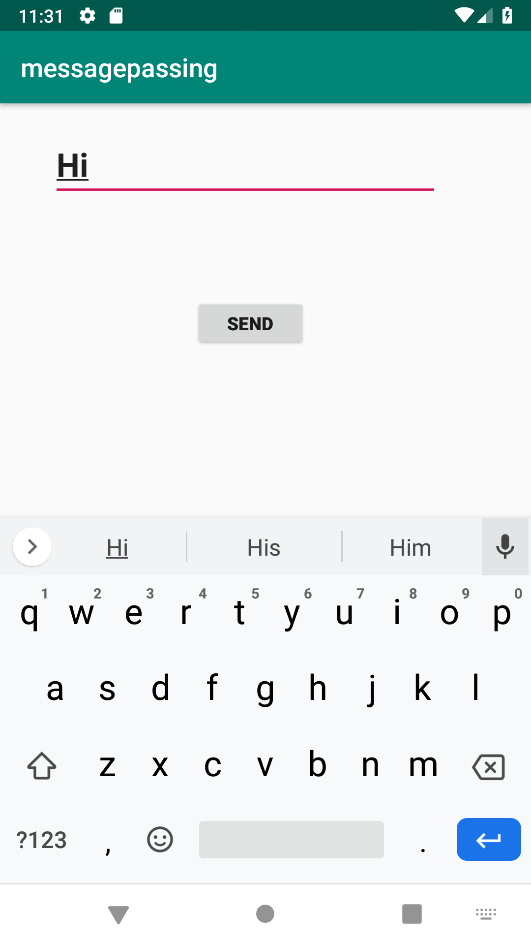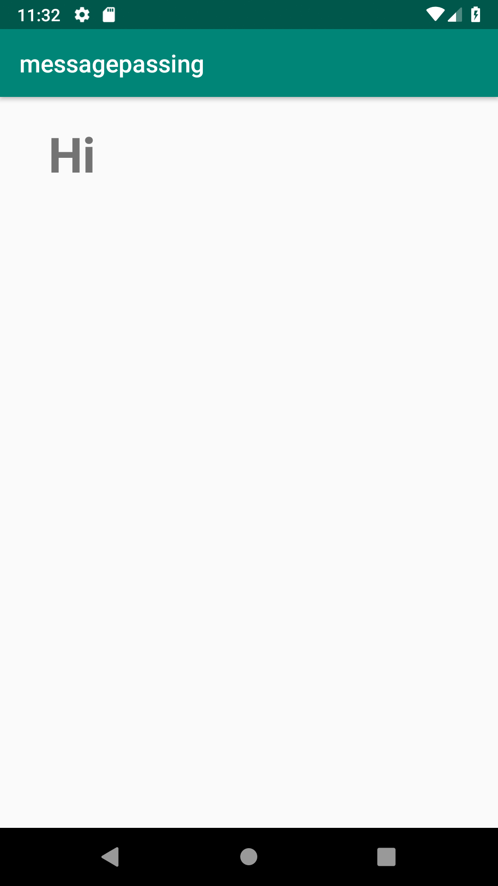

**4.****Create registration page with full validation and pass the information to the second activity (using shared preference)**

**Mandatory fields : fname,lname,gender,email,phone number,password,dob(date picker)**

**activity_main.xml**

***<?*xml version="1.0" encoding="utf-8"*?>***

<**LinearLayout xmlns:android="http://schemas.android.com/apk/res/android"**

**xmlns:tools="http://schemas.android.com/tools"**

**android:id="@+id/activity_main"**

**android:layout_width="match_parent"**

**android:layout_height="match_parent"**

**android:orientation="vertical"**

>

<**EditText**

**android:id="@+id/editTextName"**

**android:layout_width="match_parent"**

**android:layout_height="wrap_content"**

**android:ems="10"**

**android:hint="Enter First Name"**

**android:inputType="textPersonName"** />

<**EditText**

**android:id="@+id/editTextlName"**

**android:layout_width="match_parent"**

**android:layout_height="wrap_content"**

**android:ems="10"**

**android:hint="Enter Last Name"**

**android:inputType="textPersonName"** />

<**EditText**

**android:id="@+id/editTextgender"**

**android:layout_width="match_parent"**

**android:layout_height="wrap_content"**

**android:ems="10"**

**android:hint="Enter Gender"**

**android:inputType="textPersonName"** />

<**EditText**

**android:id="@+id/editTextEmail"**

**android:layout_width="match_parent"**

**android:layout_height="wrap_content"**

**android:ems="10"**

**android:hint="Enter Email"**

**android:inputType="textPersonName"** />

<**EditText**

**android:id="@+id/editTextMobile"**

**android:layout_width="match_parent"**

**android:layout_height="wrap_content"**

**android:ems="10"**

**android:hint="Enter Mobile Number"**

**android:inputType="textEmailAddress"** />

<**EditText**

**android:id="@+id/editTextDob"**

**android:layout_width="match_parent"**

**android:layout_height="wrap_content"**

**android:ems="10"**

**android:hint="Enter Date of Birth (DD/MM/YYYY)"**

**android:inputType="date"** />

<**EditText**

**android:id="@+id/editTextpassword"**

**android:layout_width="match_parent"**

**android:layout_height="wrap_content"**

**android:ems="10"**

**android:hint="Enter Password"**

**android:inputType="textPassword"** />

<**Button**

**android:id="@+id/buttonSubmit"**

**android:layout_width="match_parent"**

**android:layout_height="wrap_content"**

**android:text="Submit"** />

</**LinearLayout**>

**activity_main2.xml**

***<?*xml version="1.0" encoding="utf-8"*?>***

<**LinearLayout android:layout_width="match_parent" android:layout_height="match_parent"**

**android:orientation="vertical"**

**android:gravity="center"**

**xmlns:android="http://schemas.android.com/apk/res/android"**>

<**TextView**

**android:layout_width="match_parent"**

**android:layout_height="wrap_content"**

**android:id="@+id/tv"**

/>

</**LinearLayout**>

**MainActivity.java**

**package com.example.sjcet.regform;**

**import** android.content.Intent;

**import** android.net.Uri;

**import** android.support.v7.app.AppCompatActivity;

**import** android.os.Bundle;

**import** android.text.TextUtils;

**import** android.util.Patterns;

**import** android.view.View;

**import** android.widget.DatePicker;

**import** android.widget.EditText;

**import** android.widget.Button;

**import** android.widget.Toast;

**import** android.content.SharedPreferences;

**public class** MainActivity **extends** AppCompatActivity {

**private** EditText **editTextName**, **editTextlName**,**editTextEmail**, **editTextMobile**,

**editTextDob**, **editTextgender**,**editTextpassword**;

**private** Button **buttonSubmit**;

@Override

**protected void** onCreate(Bundle savedInstanceState) {

**super**.onCreate(savedInstanceState);

setContentView(R.layout.***activity_main***);

Button btn_Explicit = (Button)findViewById(R.id.***buttonSubmit***);

**editTextName** =findViewById(R.id.***editTextName***);

**editTextlName** =findViewById(R.id.***editTextlName***);

**editTextEmail** =findViewById(R.id.***editTextEmail***);

**editTextMobile** =findViewById(R.id.***editTextMobile***);

**editTextDob** =findViewById(R.id.***editTextDob***);

**editTextgender** =findViewById(R.id.***editTextgender***);

**editTextpassword** =findViewById(R.id.***editTextpassword***);

btn_Explicit.setOnClickListener(**new** View.OnClickListener() {

@Override

**public void** onClick(View view) {

checkDataEntered();

SharedPreferences mypref=getSharedPreferences(**"activity_main2.xml"**,0);

SharedPreferences.Editor editor=mypref.edit();*//only write editor*

editor.putString(**"fname"**,**editTextName**.getText().toString()); *//bundle the data*

editor.putString(**"lname"**,**editTextlName**.getText().toString());

editor.putString(**"gender"**,**editTextgender**.getText().toString());

editor.putString(**"phone"**,**editTextMobile**.getText().toString());

editor.putString(**"pwd"**,**editTextpassword**.getText().toString());

editor.putString(**"email"**,**editTextEmail**.getText().toString());

editor.putString(**"dob"**,**editTextDob**.getText().toString());

editor.commit();

*// String str = editTextName.getText().toString();*

*//String str1 = editTextName.getText().toString();*

Intent intent = **new** Intent(getApplicationContext(), Main2Activity.**class**);

*// intent.putExtra("message_key", str);*

startActivity(intent);

}

});

}

**boolean** isEmail(EditText text) {

CharSequence email = text.getText().toString();

**return** (!TextUtils.*isEmpty*(email) && Patterns.***EMAIL_ADDRESS***.matcher(email).matches());

}

**boolean** isEmpty(EditText text) {

CharSequence str = text.getText().toString();

**return** TextUtils.*isEmpty*(str);

}

**void** checkDataEntered() {

**if** (isEmpty(**editTextName**)) {

Toast t = Toast.*makeText*(**this**, **"You must enter first name to register!"**, Toast.***LENGTH_SHORT***);

t.show();

}

**if** (isEmpty(**editTextlName**)) {

**editTextlName**.setError(**"Last name is required!"**);

}

**if** (isEmpty(**editTextMobile**)) {

**editTextMobile**.setError(**"mobile number is required!"**);

}

**if** (isEmpty(**editTextgender**)) {

**editTextgender**.setError(**"Gender is required!"**);

}

**if** (isEmpty(**editTextpassword**)) {

**editTextpassword**.setError(**"Password is required!"**);

}

**if** (isEmpty(**editTextDob**)) {

**editTextDob**.setError(**"DOB is required!"**);

}

**if** (isEmail(**editTextEmail**) == **false**) {

**editTextEmail**.setError(**"Enter valid email!"**);

}

}

}

**Main2Activity.java**

**package com.example.sjcet.regform;**

**import** android.content.SharedPreferences;

**import** android.widget.TextView;

**import** android.content.Intent;

**import** android.support.v7.app.AppCompatActivity;

**import** android.os.Bundle;

**public class** Main2Activity **extends** AppCompatActivity {

TextView **tv**;

@Override

**protected void** onCreate(Bundle savedInstanceState) {

**super**.onCreate(savedInstanceState);

setContentView(R.layout.***activity_main2***);

**tv** =findViewById(R.id.***tv***);

Intent intent = getIntent();

SharedPreferences mypref=getSharedPreferences(**"activity_main2.xml"**,0);

String str = mypref.getString(**"tv"**,**null**);

**tv**.setText(str);

}

}

**OUTPUT**

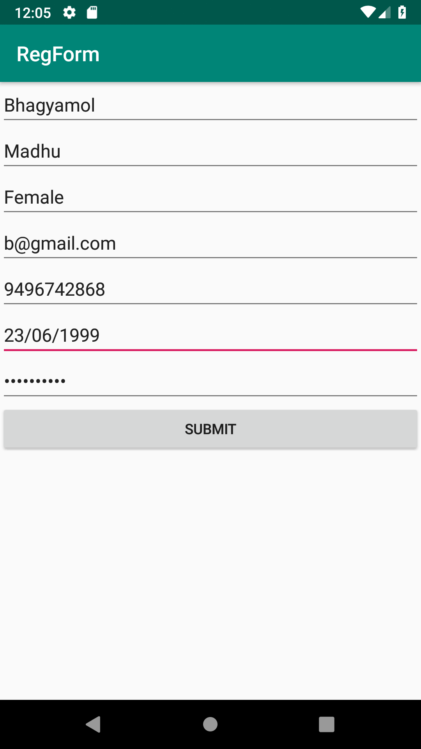

**CYCLE-3**

1. **Design a simple login page using relative layout.**

**Activity_main.xml**

<?xml version="1.0" encoding="utf-8"?>

<RelativeLayout

xmlns:android="http://schemas.android.com/apk/res/android"

xmlns:tools="http://schemas.android.com/tools"

android:id="@+id/activity_main"

android:layout_width="match_parent"

android:layout_height="match_parent"

android:background="#00CC99">

<EditText

android:id="@+id/text2"

android:layout_width="match_parent"

android:layout_height="wrap_content"

android:layout_marginLeft="18dp"

android:layout_marginRight="18dp"

android:padding="8dp"

android:background="#fff"

android:hint="Password"

android:layout_marginTop="12dp"

android:layout_below="@+id/text1" />

<Button

android:id="@+id/b1"

android:layout_width="match_parent"

android:layout_height="wrap_content"

android:text="Login"

android:textColor="#00CC99"

android:layout_below="@+id/text2"

android:layout_marginTop="17dp"

android:layout_alignStart="@+id/text2"

android:layout_alignEnd="@+id/text2" />

<TextView

android:layout_width="wrap_content"

android:layout_height="wrap_content"

android:id="@+id/text3"

android:textColor="#fff"

android:text="Not a member?Sign up now"

android:layout_below="@+id/b1"

android:layout_centerHorizontal="true"

android:layout_marginTop="34dp" />

</RelativeLayout>

**MainActivity.java**

package com.codedost.loginscreen;

import android.support.v7.app.AppCompatActivity;

import android.os.Bundle;

public class MainActivity extends AppCompatActivity {

@Override

protected void onCreate(Bundle savedInstanceState) {

super.onCreate(savedInstanceState);

setContentView(R.layout.activity_main);

}

}

**OUTPUT**

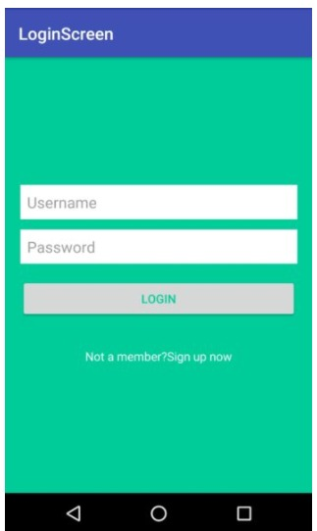

**2.Create a Array Adaptor with list view.**

**activity_main.xml**

<?xml version="1.0" encoding="utf-8"?>

<RelativeLayout

xmlns:android="http://schemas.android.com/apk/res/android"

xmlns:tools="http://schemas.android.com/tools"

android:layout_width="match_parent"

android:layout_height="match_parent"

tools:context=".MainActivity">

<ListView

android:id="@+id/simpleListView"

android:layout_width="match_parent"

android:layout_height="wrap_content" />

</RelativeLayout>

item_view.xml

<?xml version="1.0" encoding="utf-8"?>

<LinearLayout

xmlns:android="http://schemas.android.com/apk/res/android"

android:layout_width="match_parent"

android:layout_height="match_parent"

android:orientation="vertical">

<TextView

android:id="@+id/itemTextView"

android:layout_width="match_parent"

android:layout_height="wrap_content"

android:layout_gravity="center" />

</LinearLayout>

**MainActivity.java**

import android.os.Bundle;

import android.widget.ArrayAdapter;

import android.widget.ListView;

import androidx.appcompat.app.AppCompatActivity;

public class MainActivity extends AppCompatActivity {

ListView simpleListView;

// array objects

String courseList[] = {"C-Programming", "Data Structure", "Database", "Python",

"Java", "Operating System", "Compiler Design", "Android Development"};

@Override

protected void onCreate(Bundle savedInstanceState) {

super.onCreate(savedInstanceState);

setContentView(R.layout.activity_main);

simpleListView = (ListView) findViewById(R.id.simpleListView);

ArrayAdapter<String> arrayAdapter = new ArrayAdapter<String>(this,

R.layout.item_view, R.id.itemTextView, courseList);

simpleListView.setAdapter(arrayAdapter);

}

}

**OUTPUT**

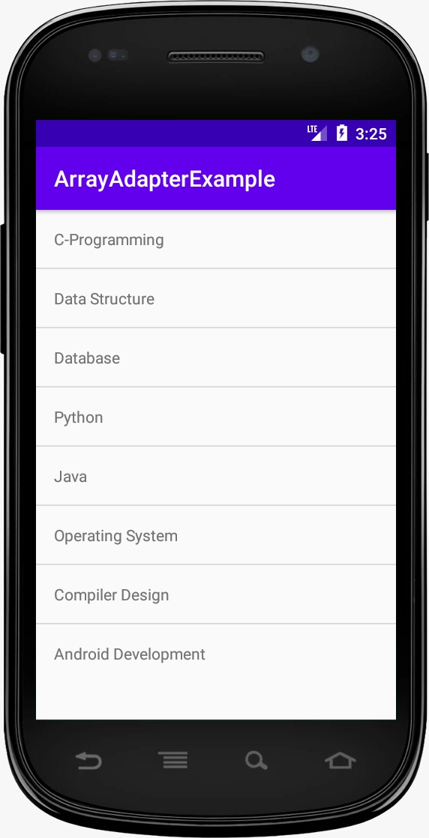

**3.Develop an application that toggle image using frame layout.**

**Activity_main.xml**

<FrameLayout xmlns:android="http://schemas.android.com/apk/res/android"

android:layout_width="fill_parent"

android:layout_height="fill_parent">

<ImageView

android:id="@+id/imageview"

android:layout_width="fill_parent"

android:layout_height="fill_parent"

android:scaleType="fitCenter"

android:src="@drawable/piq1" />

<Button

android:id="@+id/next"

android:layout_width="wrap_content"

android:layout_height="30dp"

android:layout_marginBottom="15dp"

android:layout_marginRight="10dp"

android:layout_gravity="bottom|right"

android:paddingTop="2dp"

android:paddingBottom="2dp"

android:background="@drawable/buttonback"

android:textColor="#000000"

android:text="Next" />

</FrameLayout>

**MainActivity.java**

import android.app.Activity;

import android.os.Bundle;

import android.view.View;

import android.widget.Button;

import android.widget.ImageView;

public class Piqlout extends Activity {

@Override

protected void onCreate(Bundle savedInstanceState) {

// TODO Auto-generated method stub

super.onCreate(savedInstanceState);

setContentView(R.layout.piq);

Button next= (Button) findViewById(R.id.next);

if (next.getText().equals("Next")) {

next.setOnClickListener(new View.OnClickListener() {

@Override

public void onClick(View v) {

// TODO Auto-generated method stub

ImageView img = (ImageView) findViewById(R.id.imageview);

img.setImageResource(R.drawable.piq2);

Button next= (Button) findViewById(R.id.next);

next.setText("Prev");

}

});

}

if (next.getText().equals("Prev")){

next.setOnClickListener(new View.OnClickListener() {

@Override

public void onClick(View v) {

// TODO Auto-generated method stub

ImageView img = (ImageView) findViewById(R.id.imageview);

img.setImageResource(R.drawable.piq1);

Button next= (Button) findViewById(R.id.next);

next.setText("Next");

}

});

}

}

**4.Demonstrate activity life cycle.**

**Activity_main.xml**

<?xml version="1.0" encoding="utf-8"?>

<android.support.constraint.ConstraintLayout xmlns:android="http://schemas.android.com/apk/res/android"

xmlns:app="http://schemas.android.com/apk/res-auto"

xmlns:tools="http://schemas.android.com/tools"

android:layout_width="match_parent"

android:layout_height="match_parent"

tools:context="example.javatpoint.com.activitylifecycle.MainActivity">

<TextView

android:layout_width="wrap_content"

android:layout_height="wrap_content"

android:text="Hello World!"

app:layout_constraintBottom_toBottomOf="parent"

app:layout_constraintLeft_toLeftOf="parent"

app:layout_constraintRight_toRightOf="parent"

app:layout_constraintTop_toTopOf="parent" />

</android.support.constraint.ConstraintLayout>

**MainActivity.java**

package example.javatpoint.com.activitylifecycle;

import android.app.Activity;

import android.os.Bundle;

import android.util.Log;

public class MainActivity extends Activity {

@Override

protected void onCreate(Bundle savedInstanceState) {

super.onCreate(savedInstanceState);

setContentView(R.layout.activity_main);

Log.d("lifecycle","onCreate invoked");

}

@Override

protected void onStart() {

super.onStart();

Log.d("lifecycle","onStart invoked");

}

@Override

protected void onResume() {

super.onResume();

Log.d("lifecycle","onResume invoked");

}

@Override

protected void onPause() {

super.onPause();

Log.d("lifecycle","onPause invoked");

}

@Override

protected void onStop() {

super.onStop();

Log.d("lifecycle","onStop invoked");

}

@Override

protected void onRestart() {

super.onRestart();

Log.d("lifecycle","onRestart invoked");

}

@Override

protected void onDestroy() {

super.onDestroy();

Log.d("lifecycle","onDestroy invoked");

}

}

**OUTPUT**

**You will not see any output on the emulator or device. You need to open logcat.**

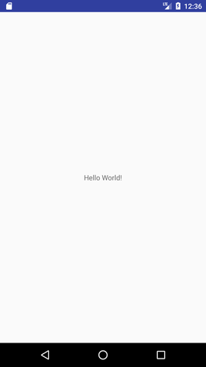

**Now see on the logcat: onCreate, onStart and onResume methods are invoked.**

**Now click on the HOME Button. You will see onPause method is invoked**

**Now see on the emulator. It is on the home. Now click on the center button to launch the app again.**

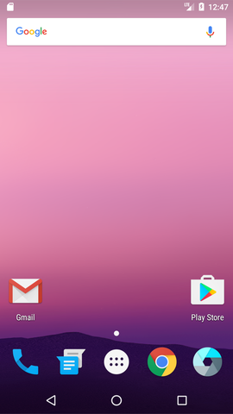

**Now click on the lifecycleactivity icon.**

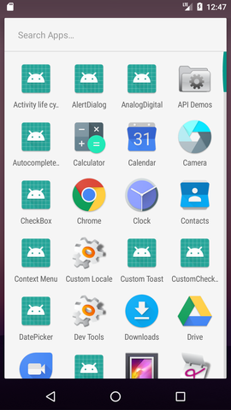

**Now see on the logcat: onRestart, onStart and onResume methods are invoked.**

**If you see the emulator, application is started again.**

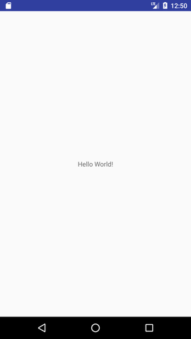

**5.Taking camera and saving the picture.**

**Mainactivity.xml**

<?xml version="1.0" encoding="utf-8"?>

<RelativeLayout xmlns:android="https://schemas.android.com/apk/res/android"

xmlns:app="https://schemas.android.com/apk/res-auto"

xmlns:tools="https://schemas.android.com/tools"

android:id="@+id/content_main"

android:layout_width="match_parent"

android:layout_height="match_parent"

android:paddingBottom="@dimen/activity_vertical_margin"

android:paddingLeft="@dimen/activity_horizontal_margin"

android:paddingRight="@dimen/activity_horizontal_margin"

android:paddingTop="@dimen/activity_vertical_margin"

android:background="#000000"

app:layout_behavior="@string/appbar_scrolling_view_behavior"

tools:context="com.journaldev.imagepicker.MainActivity"

tools:showIn="@layout/activity_main">

<RelativeLayout

android:layout_width="250dp"

android:layout_height="250dp"

android:layout_centerHorizontal="true"

android:layout_centerVertical="true"

android:background="@drawable/image_border"

android:clickable="true"

android:orientation="vertical">

<ImageView

android:id="@+id/imageView"

android:layout_width="match_parent"

android:layout_height="match_parent"

android:adjustViewBounds="true"

android:scaleType="centerCrop" />

</RelativeLayout>

<de.hdodenhof.circleimageview.CircleImageView

android:id="@+id/img_profile"

android:layout_width="100dp"

android:layout_height="100dp"

android:layout_gravity="center_horizontal"

android:src="@drawable/profile"

app:civ_border_width="5dp"

app:civ_border_color="#FFFFFF"

android:layout_alignParentBottom="true"

android:layout_centerHorizontal="true" />

</RelativeLayout>

**MainActivity.java**

public class MainActivity extends AppCompatActivity {

Bitmap myBitmap;

Uri picUri;

private ArrayList permissionsToRequest;

private ArrayList permissionsRejected = new ArrayList();

private ArrayList permissions = new ArrayList();

private final static int ALL_PERMISSIONS_RESULT = 107;

@Override

protected void onCreate(Bundle savedInstanceState) {

super.onCreate(savedInstanceState);

setContentView(R.layout.activity_main);

Toolbar toolbar = (Toolbar) findViewById(R.id.toolbar);

setSupportActionBar(toolbar);

FloatingActionButton fab = (FloatingActionButton) findViewById(R.id.fab);

fab.setOnClickListener(new View.OnClickListener() {

@Override

public void onClick(View view) {

startActivityForResult(getPickImageChooserIntent(), 200);

}

});

permissions.add(CAMERA);

permissionsToRequest = findUnAskedPermissions(permissions);

//get the permissions we have asked for before but are not granted..

//we will store this in a global list to access later.

if (Build.VERSION.SDK_INT >= Build.VERSION_CODES.M) {

if (permissionsToRequest.size() > 0)

requestPermissions(permissionsToRequest.toArray(new String[permissionsToRequest.size()]), ALL_PERMISSIONS_RESULT);

}

}

@Override

public boolean onCreateOptionsMenu(Menu menu) {

// Inflate the menu; this adds items to the action bar if it is present.

getMenuInflater().inflate(R.menu.menu_main, menu);

return true;

}

@Override

public boolean onOptionsItemSelected(MenuItem item) {

// Handle action bar item clicks here. The action bar will

// automatically handle clicks on the Home/Up button, so long

// as you specify a parent activity in AndroidManifest.xml.

int id = item.getItemId();

//noinspection SimplifiableIfStatement

if (id == R.id.action_settings) {

return true;

}

return super.onOptionsItemSelected(item);

}

/**

* Create a chooser intent to select the source to get image from.<br />

* The source can be camera's (ACTION_IMAGE_CAPTURE) or gallery's (ACTION_GET_CONTENT).<br />

* All possible sources are added to the intent chooser.

*/

public Intent getPickImageChooserIntent() {

// Determine Uri of camera image to save.

Uri outputFileUri = getCaptureImageOutputUri();

List allIntents = new ArrayList();

PackageManager packageManager = getPackageManager();

// collect all camera intents

Intent captureIntent = new Intent(android.provider.MediaStore.ACTION_IMAGE_CAPTURE);

List listCam = packageManager.queryIntentActivities(captureIntent, 0);

for (ResolveInfo res : listCam) {

Intent intent = new Intent(captureIntent);

intent.setComponent(new ComponentName(res.activityInfo.packageName, res.activityInfo.name));

intent.setPackage(res.activityInfo.packageName);

if (outputFileUri != null) {

intent.putExtra(MediaStore.EXTRA_OUTPUT, outputFileUri);

}

allIntents.add(intent);

}

// collect all gallery intents

Intent galleryIntent = new Intent(Intent.ACTION_GET_CONTENT);

galleryIntent.setType("image/*");

List listGallery = packageManager.queryIntentActivities(galleryIntent, 0);

for (ResolveInfo res : listGallery) {

Intent intent = new Intent(galleryIntent);

intent.setComponent(new ComponentName(res.activityInfo.packageName, res.activityInfo.name));

intent.setPackage(res.activityInfo.packageName);

allIntents.add(intent);

}

// the main intent is the last in the list (fucking android) so pickup the useless one

Intent mainIntent = allIntents.get(allIntents.size() - 1);

for (Intent intent : allIntents) {

if (intent.getComponent().getClassName().equals("com.android.documentsui.DocumentsActivity")) {

mainIntent = intent;

break;

}

}

allIntents.remove(mainIntent);

// Create a chooser from the main intent

Intent chooserIntent = Intent.createChooser(mainIntent, "Select source");

// Add all other intents

chooserIntent.putExtra(Intent.EXTRA_INITIAL_INTENTS, allIntents.toArray(new Parcelable[allIntents.size()]));

return chooserIntent;

}

/**

* Get URI to image received from capture by camera.

*/

private Uri getCaptureImageOutputUri() {

Uri outputFileUri = null;

File getImage = getExternalCacheDir();

if (getImage != null) {

outputFileUri = Uri.fromFile(new File(getImage.getPath(), "profile.png"));

}

return outputFileUri;

}

@Override

protected void onActivityResult(int requestCode, int resultCode, Intent data) {

Bitmap bitmap;

if (resultCode == Activity.RESULT_OK) {

ImageView imageView = (ImageView) findViewById(R.id.imageView);

if (getPickImageResultUri(data) != null) {

picUri = getPickImageResultUri(data);

try {

myBitmap = MediaStore.Images.Media.getBitmap(this.getContentResolver(), picUri);

myBitmap = rotateImageIfRequired(myBitmap, picUri);

myBitmap = getResizedBitmap(myBitmap, 500);

CircleImageView croppedImageView = (CircleImageView) findViewById(R.id.img_profile);

croppedImageView.setImageBitmap(myBitmap);

imageView.setImageBitmap(myBitmap);

} catch (IOException e) {

e.printStackTrace();

}

} else {

bitmap = (Bitmap) data.getExtras().get("data");

myBitmap = bitmap;

CircleImageView croppedImageView = (CircleImageView) findViewById(R.id.img_profile);

if (croppedImageView != null) {

croppedImageView.setImageBitmap(myBitmap);

}

imageView.setImageBitmap(myBitmap);

}

}

}

private static Bitmap rotateImageIfRequired(Bitmap img, Uri selectedImage) throws IOException {

ExifInterface ei = new ExifInterface(selectedImage.getPath());

int orientation = ei.getAttributeInt(ExifInterface.TAG_ORIENTATION, ExifInterface.ORIENTATION_NORMAL);

switch (orientation) {

case ExifInterface.ORIENTATION_ROTATE_90:

return rotateImage(img, 90);

case ExifInterface.ORIENTATION_ROTATE_180:

return rotateImage(img, 180);

case ExifInterface.ORIENTATION_ROTATE_270:

return rotateImage(img, 270);

default:

return img;

}

}

private static Bitmap rotateImage(Bitmap img, int degree) {

Matrix matrix = new Matrix();

matrix.postRotate(degree);

Bitmap rotatedImg = Bitmap.createBitmap(img, 0, 0, img.getWidth(), img.getHeight(), matrix, true);

img.recycle();

return rotatedImg;

}

public Bitmap getResizedBitmap(Bitmap image, int maxSize) {

int width = image.getWidth();

int height = image.getHeight();

float bitmapRatio = (float) width / (float) height;

if (bitmapRatio > 0) {

width = maxSize;

height = (int) (width / bitmapRatio);

} else {

height = maxSize;

width = (int) (height * bitmapRatio);

}

return Bitmap.createScaledBitmap(image, width, height, true);

}

/**

* Get the URI of the selected image from {@link #getPickImageChooserIntent()}.<br />

* Will return the correct URI for camera and gallery image.

*

* @param data the returned data of the activity result

*/

public Uri getPickImageResultUri(Intent data) {

boolean isCamera = true;

if (data != null) {

String action = data.getAction();

isCamera = action != null && action.equals(MediaStore.ACTION_IMAGE_CAPTURE);

}

return isCamera ? getCaptureImageOutputUri() : data.getData();

}

@Override

protected void onSaveInstanceState(Bundle outState) {

super.onSaveInstanceState(outState);

// save file url in bundle as it will be null on scren orientation

// changes

outState.putParcelable("pic_uri", picUri);

}

@Override

protected void onRestoreInstanceState(Bundle savedInstanceState) {

super.onRestoreInstanceState(savedInstanceState);

// get the file url

picUri = savedInstanceState.getParcelable("pic_uri");

}

private ArrayList findUnAskedPermissions(ArrayList wanted) {

ArrayList result = new ArrayList();

for (String perm : wanted) {

if (!hasPermission(perm)) {

result.add(perm);

}

}

return result;

}

private boolean hasPermission(String permission) {

if (canMakeSmores()) {

if (Build.VERSION.SDK_INT >= Build.VERSION_CODES.M) {

return (checkSelfPermission(permission) == PackageManager.PERMISSION_GRANTED);

}

}

return true;

}

private void showMessageOKCancel(String message, DialogInterface.OnClickListener okListener) {

new AlertDialog.Builder(this)

.setMessage(message)

.setPositiveButton("OK", okListener)

.setNegativeButton("Cancel", null)

.create()

.show();

}

private boolean canMakeSmores() {

return (Build.VERSION.SDK_INT > Build.VERSION_CODES.LOLLIPOP_MR1);

}

@TargetApi(Build.VERSION_CODES.M)

@Override

public void onRequestPermissionsResult(int requestCode, String[] permissions, int[] grantResults) {

switch (requestCode) {

case ALL_PERMISSIONS_RESULT:

for (String perms : permissionsToRequest) {

if (hasPermission(perms)) {

} else {

permissionsRejected.add(perms);

}

}

if (permissionsRejected.size() > 0) {

if (Build.VERSION.SDK_INT >= Build.VERSION_CODES.M) {

if (shouldShowRequestPermissionRationale(permissionsRejected.get(0))) {

showMessageOKCancel("These permissions are mandatory for the application. Please allow access.",

new DialogInterface.OnClickListener() {

@Override

public void onClick(DialogInterface dialog, int which) {

if (Build.VERSION.SDK_INT >= Build.VERSION_CODES.M) {

//Log.d("API123", "permisionrejected " + permissionsRejected.size());

requestPermissions(permissionsRejected.toArray(new String[permissionsRejected.size()]), ALL_PERMISSIONS_RESULT);

}

}

});

return;

}

}

}

break;

}

}

}